Table of Contents

About SuperTyperTrainer: 2

Program Pseudocode: 4

# About SuperTyperTrainer:

The program will allow people to train to type faster. It will use a simple interface showing the layout of the keyboard towards the bottom of the screen and large, easy to read letters will move across the center of the screen. Initially, the letters will move slowly from right to left but gradually progress faster and faster as user becomes proficient in typing.

Screen Layout:

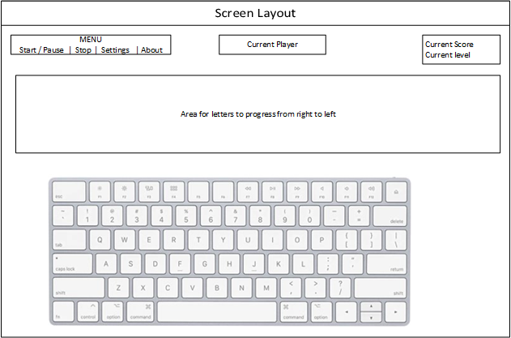

The first letter of the letter train will be highlighted in green background on the keyboard to help the person know where the keys are located. An incorrect key press will show in RED highlight and a short incorrect sound will play. If the correct key is pressed, a short correct sound will play.

Once the trainee has reached a certain level, the keyboard will disappear. Current player shown in the middle. Total score and current level will be displayed as well.

For the Menu:

Start button – Starts the sequence of letters and changes to Pause

Pause button – Pauses the sequence of letters and changes to Start

Stop button – Stops the sequence and resets the screen. Also saves all progress so far.

Settings button – Opens another screen that allows the user to change players and change current level.

About button – Opens a modal window that displays information about the program such as revision and programmers.

# Program Pseudocode:

**Main Program:**

1. Setup and register program with Windows
2. Setup and load Screen
   1. Setup / Load Menu
   2. Setup / Load Current Player
   3. Setup / Load Current Level and Score
   4. Setup / Load Keyboard view
3. Wait and Respond to User commands
   1. User Clicks Start Button
      1. Only available if user sets up a profile by clicking settings, otherwise grayed out.
      2. Button changes to Pause Button
      3. Start Typer Routine
   2. User Clicks Settings button
      1. Not available if Typer Routine is functioning
      2. Brings up user profile selection page
   3. User Clicks About button
      1. Brings up a dialogue box about the program and the software engineer

**Typer Routine:**

1. Provides the timing, level, and scoring of the game portion of the program.

**Profile Selection Page:**

1. User Name Selection
   1. Can add new user
   2. Can delete existing user
   3. Can rename a user
2. Current Level
   1. Shows how fast letters appear
   2. Indicates if numbers, capital letters, or symbols are active
3. Current Score

